Inquiry Question: How are the people in the letters connected and what is their relationship with one another like?

Interview (Modified)
August 6, 1937
Doc Edwards-84 years old
Former Slave

I was born in 1853 in Staggville, North Carolina. I belonged to Master Paul Cameron. My pappy was Murphy McCullers and mammy’s name was Judy. That means that I am a McCullers but, I have always been called Doc Edwards. I am still called Doc Edwards to this day.
I was raised to be the houseman and I cooked for Master Benehan, Master Paul’s son. Master Benehan was good to me. When my health failed from doing so much work in the house I would go for a couple of hours each day and work in the field and get well again.
Master Paul had so many slaves that he never counted them. When we opened the gate for him or met him in the road he would say, “Who is you? Where do you belong”. We would say, “We belong to Master Paul”. “Alright, run along”, he’d say. Then he would throw us a nickel or so.
We had big work shops where we made all of the tools even shovels. They were made out of wood and so were the rakes, pitchforks, and hoes. Our nails were made by hand in the blacksmith shop along with picks and grubbin’ hoes, too.
We had a hand thrashing machine too. It was round like a stove pipe, only bigger. We fed the weat to it and it shook the wheat until it was loose from the straw and then it would come out of the other end and fall on a big cloth that was bigger than sheets. We had big curtains all around the cloth on the floor so that the wheat wouldn’t get scattered all around. Then we took the pitchfork and lifted the straw up and down so the wheat would go on the cloth. Then we moved the straw when the wheat was all loose. Then we fanned the wheat with big pieces of cloth to get the dust and dirt out of it. Then it could be taken to the mill and ground when they wanted it to be.
When the fall came we had a regular place to do different work. We had hand looms and wove cotton and yarn to make cloth and clothes for us to wear.
We had a shop where our shoes were made. The cobbler would make our shoes with wooden soles. After the soles were cut out they would be taken down to the blacksmith and he would put a thin rim of iron around the soles to keep them from splitting. These soles were made from maple and ash wood.
We didn’t have any horses to haul with. We used oxen and ox-carts. The horse and mules were used to do the plowin’.
When the Yankees came they didn’t do so much harm, they told us we were free. But, I always feel like I belong to Master Paul, and I still live at Staggville on the old plantation. I have a little garden and do what I can to earn a little something. The law has fixed it so I will get a little pension, and I’ll stay right on in that little house ‘til the good Lord calls me home, then I will see Master Paul once more.

Envelope(Modified and shortened)
Return Address:
Hobbie, Ala.
Nov. 18

Addressed to:
Duncan Cameron
Raleigh, North Carolina
Letter, page 1

Greene Co. Ala., Nov. 18, 1845, Monday

My Dear Father,

Letters were sent to you and Anne to inform you that I am on my way to Montgomery and arrived at Greensboro in a week from Raleigh. I will be delayed 24 hours because of the steam boat at Montgomery waiting to depart. I arrived here on Tuesday morning. I met with a pretty nice reception from overseer and Negroes, a large portion of whom seem very much pleased to see me. Everyone was not well enough to greet me though. Little Joe is still sick. Sandy is looking badly. Henderson is the same as he was a year ago but, looks a little more pale and feeble if that is possible. Yesterday, as is tradition on the plantation, all of the negroes appeared in line before the overseer’s door for inspection of their clothing and persons. They looked good for the most part. They were clean and their clothes were good. The young adult members of the family look very well. The elder ones are looking thin and pale. The children are as fat as pigs. The elder ones are very tired of their diet of pickled pork. They have a different crop of vegetables with the exception of turnips. We do not have fish and we need to buy some bacon because, we only have a week’s provision on hand. Mr. Lewellyn has done a good job with keeping the house and with using the money. The corn crop should be good but, Lewellyn and I have talked about how it could be too high. There should be enough for family, horses, and the hogs. I think the crop is way below the estimate of the overseer. There has been from 6-800 barrels of corn made. The oats were stacked poorly and could have been hurt by the bad stacking but, I had the stacks restacked. I hope to get seed from them.
Every effort is being made to save the cotton crop but, our people are not good pickers. A few did pick as high as 200 pounds a day but, many picked less than a hundred. We get from 6-7000 pounds a day. In reference to the cotton crop, 14 days have been lost by rain, and consequently we lost a lot of crop. We have 173 bags at the landing, and as reported by Leewellyn 140 in the blow rooms, and 20 in seed. If he is correct, the crop saved is equal to 233 bags. The gin house list of weights is pretty good and I hope average 500. Lewellyn says that if he can save some more he will make a crop of 350 bags. I don’t think he will get much over 300 bags. Being able to save all of the cotton without trash in it is out of the question. This week has had good weather and we have made good use of it. One night of rain or one storm could nearly destroy it all. The amount of land here could make 5 to 600 possibly even 700 bags on other estates.
The overseer Mr. Lewellyn will be employed with us again next year. I do not like everything about him but, there is nothing I can do about it now. I see and hear a lot of things that I do approve of. He has made the manners and customs of our people increase. He has improved their capacity and disposition to labor. He has made the rude orderly and respectful. He is at ease with his job. I have heard that he kind to the sick but, mostly keeps to himself. He hasn’t had nor have I heard of any visitors. I think he likes me but, it is not really important since I don’t live near him. The negroes fear him a little too much for my liking but they claim that he is kind.
I hope that I don’t have to stay here for the winter. I will try and work through and work it out. God bless you forever my dear father. May I be able to make you more proud of me and prove to you that no father ever had a son that loves their father as much as I love you. Peace be with you. God bless all.

P.C. Cameron

P.S. I don’t desire any but yourself and uncle to read this letter.

Below you have a list of the cotton pickers and the quantity picked by each yesterday, Monday November 18th.

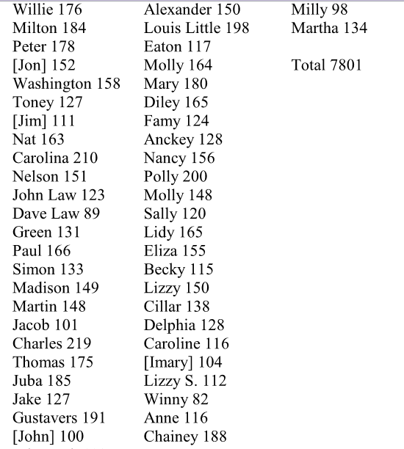

Cy Hart, 78 years old (modified)
Ex-slave

My father’s name was Ephram Hart and my mama’s name was Nellie. He belonged to Master Ephram Hart. One day Master Hart took some of his slaves to the slave market and my father was one of the slaves he took. Master Paul Cameron bought him. Then Master Hart felt so sorry to think he had let my father be sold and he tried to buy him back from Master Paul. He even offered Master Paul more than Master Paul had paid for him. Master Paul wouldn’t sell him back he said, “No, Sir. I done bought him and I am going to take him home with me to Snow Hill farm”.
My fathered married my mother and raised a family on Master Paul’s planation. We had to be eight years old before we could work. I took care of the chickens, turkeys, and such. I helped tend to the other livestock too as I got older. I also did anything I was told to do. When I got bigger I helped them with the wheat thrashin’ and I helped them push straw to the stack.
We had what was then called a “Ground hog”. It was a cylinder shaped contraption. We put the wheat and straw in it to knock the grain loose from the straw. Then we took the pitchforks and tossed the straw up and about and let it go to the bottom of a big cloth. Then we [fan] the wheat, to get the dust and dirt out. We had big curtains hung around the cloth where the wheat was sacked and when we wanted we took the wheat to the mill and ground it into flour. The flour was made into white bread and the corn was ground into meal and grits.
When the war started there was some bad times. One day some of Wheeler’s men came and they tried to take what they wanted but, Master Paul had the silver and other things hid. They wanted us slaves to tell them where everything was but, we said we didn’t know nothing. Master Paul was hiding in the woods with some of the horses and other livestock. One of Wheeler’s men saw the Yankees coming and they ran away. The Yankees chased them down to the bridge […] they came fighting and one or two of Wheeler’s men were killed but, the rest got away.
Then the captain of the Yankees came to the house and he wanted food. She told him that father had the keys to go and ask him. The captain said, “ask him nothing”. He called some of his men and they broke down the door to the meat house. They threw out plenty of the hams and they told mother to cook them something to eat and plenty of it. Mother fired plenty of that ham, lots of bread, and fixed them coffee. They were just as nice as they could be to mother and when they were through, they told mother that she could have a rest. The captain gave her some money and told her that she was free and that we didn’t belong to Master Paul any more. They did not come to do any harm to the place. They were just looking for something to eat. Then they left.
We didn’t’ leave Master Paul but, stayed and lived with him for many years. I lived with Master Paul until he died and he had eight of us negroes to tote his coffin to the chapel and to the buryin’ ground. He said, “I want these negroes to carry my body to the chapel and to the grave when I die”. We did. It was a load I wished that we had two or four more people to help with. Master Paul sure was heavy. After everything was ready we lifted him up and toted him to the chapel and we sat down on the floor on each side of his coffin while the preacher preached his funeral. We didn’t’ make any fuss while we were sitting on the floor, but we sure were full of grief to see our dear Master Paul lying there dead.

Envelope(Modified)
Return Address:
Hobbie, Ala.
Feb14th

Addressed to:
Mr. P. C. Cameron
Stagville Post Office
Orange County, North Carolina

Green County, Alabama
February 13th, 1846

Mr. Cameron
Dear Sir,

It is raining and has rained every Friday since you left here. Old York is not in her house yet. Little Joe has not improved much if any. Henderson is the same as he was when you left here. Willie’s foot is not better than it was when you left here. Fanny is complaining as usual. The things that you sent up on the boat when Mr. Vest came up has been received. I do not have any mules yet. They are very [unintelligible] I think. I have more land plowed now compared to this time last year. I know my team is in better order and I think they have improved since you left. I shall begin sowing oats as soon as my land is dry enough for me to begin the process.
Yours very respectfully,
Charles Lewellyn

