Cultivating a Revolution Lesson Guide:

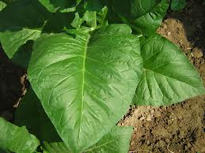
“Time Lapse Photography of a Tobacco Leaf,” by Delmas H. Petrea:: Fertilization Studies
(Charles W. Suggs Papers, 1914-1995 (mc00033)
http://d.lib.ncsu.edu/collections/catalog/mc00033-003-bx0011-007-000
Students will focus on the document developed by Delmas H. Petrea that describes how he took time lapse photography of a tobacco leaf. The entire collection of documents on this topic can be found at: http://d.lib.ncsu.edu/collections/catalog?f%5Bispartof_facet%5D%5B%5D=Cultivating+a+Revolution
Standards: The Common Core standards used in this lesson guide are: 8. RIT.1, 8. RIT.4, 8.H.1.2, 8. H.3.2, 8. L.3.1, & 8. L.2.1. (An expanded listing of the standards is attached)
[NOTE: Student tasks are in bold for facilitator’s convenience.]
Background/ Document Summary:
Delmas Petrea wanted to create a movie from still images of a tobacco leaf to show a time lapse of how the leaf grew. Petrea also wanted to be able to measure the leaf’s growth and show the leaf’s progress in the photography. Showing how the leaf grew proved to be problematic for Petrea. He tried using house paint, ink, etc. to measure the growth of the leaf but, those materials damaged the leaf. Finally, Petrea settled upon using watercolor paint. Watercolor paint is not toxic so it did not harm the leaf but, it would wash away after a few days. The document that is written by Petrea is five pages long and includes information about two time lapse movies. Petrea informs readers of a third project that is still in progress.
- Have students access and read the entire document. The document can be accessed through print or digital means.
Unfamiliar words.
Words such as: elongation, ascertained, obliquely, and concentration are used within the text. Students will be able to use context clues to determine the connotative meaning, tone, and impact of the word choice used by the author. Concentration, for example, is not used to describe a person concentrating on a task; rather it is used to describe the amount of something present. Students may not be familiar with that form of the word concentration or the other words within the text that can be analyzed according to the Common Core standard 8.RIT.4.
- Have students use the attached graphic organizer to define unfamiliar words (3 word minimum).
- Have students answer the following prompt: Upon reading the Petrea document explain what Petrea’s goal was, describe the processes he took to reach his goal, and include whether or not Petrea successfully achieved his goal. Support your answer using evidence from the text.
- Instruct students to research the pros and cons of fertilizer as well as how it has changed over the years. (NOTE: Students are expected to already have some background knowledge about the factors needed for the survival of ecosystems since, it is covered in 5th Grade, 6th Grade, and 8th Grade) Upon completion of the research students should be able to answer the following questions:
- Is fertilizer a good thing?
- *Think about how technology has evolved since this document was written on the typewriter and how that would affect a re-enactment of this experiment. If you were to re-enact Petrea’s experiment would you do things differently?
  - Describe what you would change. Explain why you would leave things the same.
- Was Petrea’s experiment ethical? (The goal is for students to analyze and answer the question based on the harming of the leaves and not to discredit Petrea in any way)
- Based on your knowledge of what producers need to survive, did the producers described in the document have what they needed?
Graphic organizer that students can use to help them with unfamiliar words. Students can find/add: clue words, the connotation of the word, the impact and tone of the word, the main idea (To help put the word in context), their definition for the word, and the official definition. Students can be given a blank copy or draw their own in their notebooks using the labels.
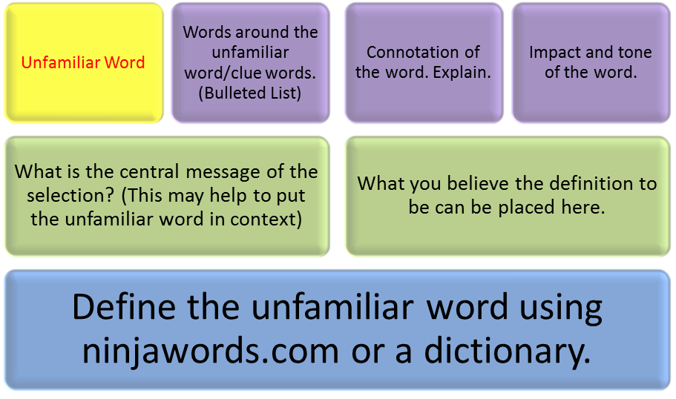
Student Task Sheet is attached and labeled: “Time Lapse Photography of a Tobacco Leaf Lesson”. Print or display the task sheet for students to complete.
“Time Lapse Photography of a Tobacco Leaf Lesson”

- Access and read the document by following the link below. http://d.lib.ncsu.edu/collections/catalog/mc00033-003-bx0011-007-000
- Use the attached graphic organizer to define unfamiliar words (3 word minimum).
- Prompt: Upon reading the Petrea document explain what Petrea’s goal was, describe the processes he took to reach his goal, and include whether or not Petrea successfully achieved his goal. Support your answer using evidence from the text.
- Research the pros and cons of fertilizer as well as how it has changed over the years. After completing the research answer the following question:
  - Is fertilizer a good thing?
- *Think about how technology has evolved since this document was written on the typewriter and how that would affect a re-enactment of this experiment.
  - If you were to re-enact Petrea’s experiment would you do things differently?
    - Describe what you would change.
    - Explain why you would leave things the same.
- Was Petrea’s experiment ethical?
- Based on your knowledge of what producers need to survive, did the producers described in the document have what they needed?
______________________________________________________________________
*Graphic organizer to help define unfamiliar words.
Please draw the organizer out for each unfamiliar word (minimum of 3 words) on blank paper.

Standards addressed by this lesson:
Standards: The Common Core standards used in this lesson guide are: 8. RIT.1, 8. RIT.4, 8.H.1.2, 8. H.3.2, 8. L.3.1, & 8. L.2.1.
- 8. RIT.1 Cite the textual evidence that most strongly supports an analysis of what the text says explicitly as well as inferences drawn from the text. (Reading Standard)
- 8. RIT.4 Determine the meaning of words and phrases as they are used in a text, including figurative, connotative, and technical meanings; analyze the impact of specific word choices on meaning and tone, including analogies or allusions to other texts. (Reading standard)
- 8.H.1.2 Summarize the literal meaning of historical documents in order to establish context (Social Studies Standard)
- 8. H.3.2 Explain how changes brought about by technology and other innovations affected individuals and groups in North Carolina and the United States. (Social Studies Standard)
- 8. L.2.1 Summarize aspects of biotechnology including: …Ethical issues and Implications for agriculture. (Science Standard)
- 8. L.3.1 Explain how factors such as food, water, shelter, and space affect populations in an ecosystem. (Science Standard)

